TAYSIDE MACHINERY LTD
SCOTLAND
TELE: 0044 (0) 1382 200797 FAX: 0044 (0) 1382 202853
e-mail: sales@taysidemachinery.co.uk website: www.taysidemachinery.co.uk

XYZ XL 780 CNC Lathe
ST3548

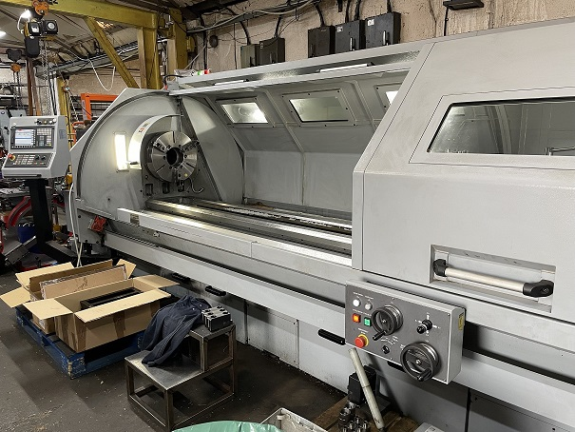

XYZ XL 780 CNC Lathe

Model: XL780
Year: 2015
Control: Siemens 828D with ShopTurn

Swing over Bed: 780mm
Swing over Cross Slide: 535mm
Swing in Gap: 1090mm
Distance Between Centres: 3000mm

Spindle Bore: 160mm dia.
Spindle Speeds: 20 – 1300 rpm

